**Live Covid-19 Dashboard Using Power BI**

**Definition :** To build an attractive and unique Covid-19 Power BI dashboard.

**Problem Statement** : The pandemic SaR-Cov-19 rises exponentially day-by-day and datasets are also updated daily so due to this, there are many problems in building a Live Dashboard.

**Technical Analysis** :





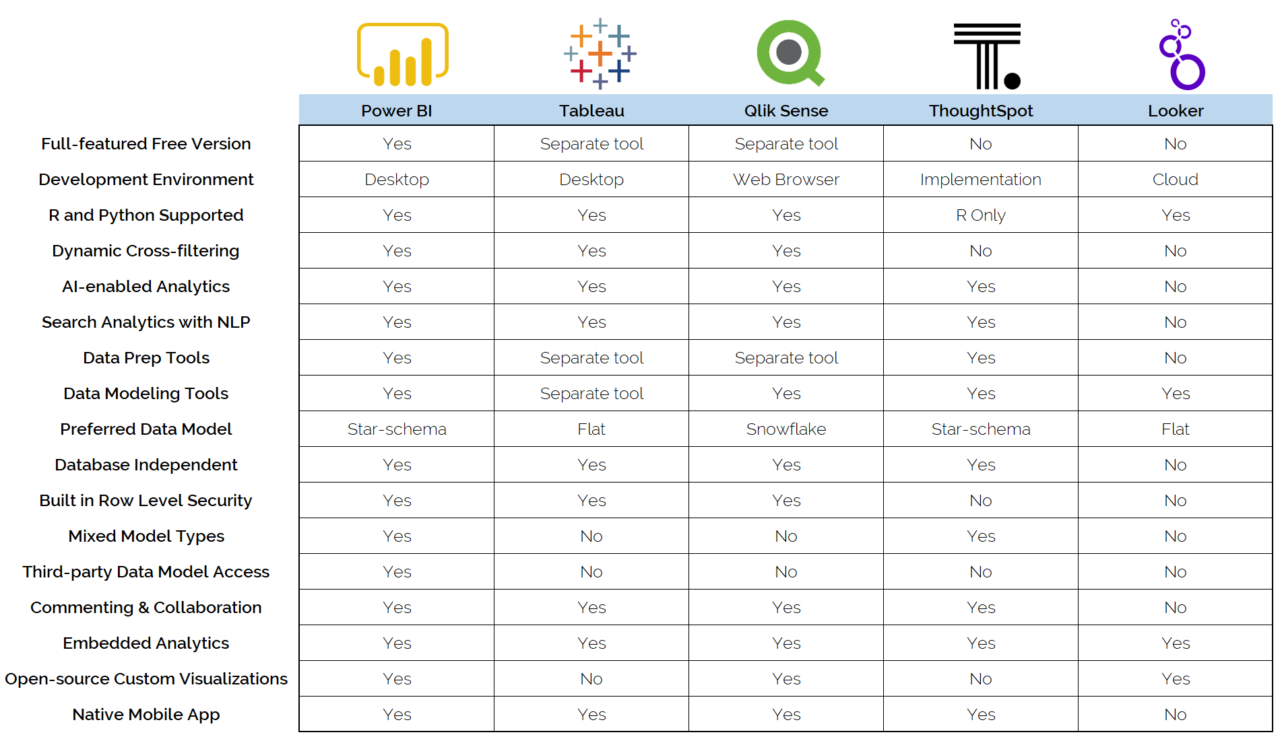

% increase in usage by Google Trend

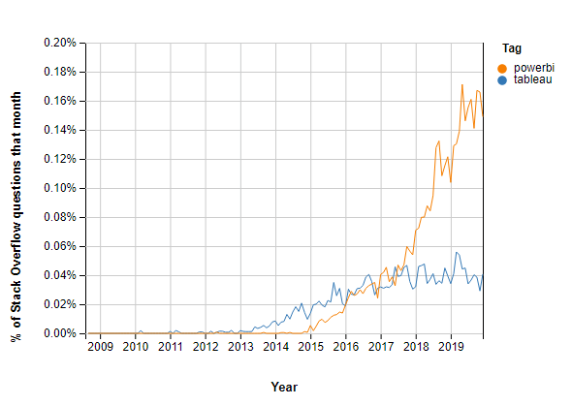

**Applications of Power BI :**

* Automate KPIs in **Microsoft Power BI**. ...
* Visualize Sales Versus Marketing Leads. ...
* Conduct a Marketing Health Check. ...
* Gain a Real-Time Look at Your Company's Financial Performance. ...
* Create Consistent Reporting Standards. ...
* Stay Ahead of Inventory Shortages.